**Global Warming in Adelaide Data Analysis and Visualization**

**Author: Cynthia Mueni Kiiti**

**Introduction**

This analysis and visualization of temperature data in Adelaide aims to shed light on key aspects of fluctuations in the temperature in the state and whether it is affected by global warming. This will be conducted by tracking a total of two datasets pertaining to minimum and maximum temperature within Adelaide. These datasets contain information regarding the daily minimum temperature from 16th February 1955 to 9th October 2023 and the daily maximum temperature from 16th February 1955 to 8th October 2023. For this analysis we will assume that the highest temperature is recorded during the day and the lowest temperature during the night to allow for easier comparison.

For the dataset containing information on the minimum daily temperature, it is structured with columns representing the produce code, Bureau of Meteorology station number, Year, Month, Date, Minimum Temperature, Days of accumulation of minimum temperature and Quality. The ‘Minimum Temperature’ column predominantly contains the daily minimum temperature reported in Adelaide and, as such, our primary focus will be directed towards this variable.

Furthermore, the dataset containing information on the maximum daily temperature, exhibit similarities with the minimum daily temperature datasets, featuring variables similar to those previously mentioned. Specifically, the ‘Maximum Temperature’ variable is of significance.

According to the Maximum Temperature dataset, the maximum day temperature is 45.80°C while the minimum day temperature is 9.40°C. On average, the temperature during the day is 21.53°C. Meanwhile according to the Minimum Temperature dataset, the maximum night temperature is 33.50°C while the minimum night temperature is -2.60°C. On average, the temperature at night is 11.49°C. Below are the results of the descriptive statistics:

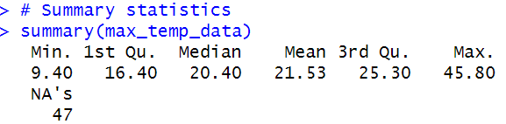

The month when the highest day temperature was observed is January while the month when the lowest day temperature was observed is July. In contrast, the month when the highest night temperature was observed is January while the month when the lowest night temperature was observed is June. It is therefore possible to conclude that January is the hottest month of the year while the coldest times of the year are around June-July.

**50-Year Day Temperatures Comparison between July 1961 and July 2021.**

This comparison aims to evaluate any differences between the day temperatures between the two periods. July was chosen for this analysis as it showed up earlier in the analysis as the coldest month of the year, and a comparison for these two years would provide additional insights about the winter season in Adelaide.

For July 1961, the average day temperature is 14.5°C while for July 2021, the average day temperature is 15.2°C. Over the 50 years, the mean daily temperature seems to have increased by 0.7°C, indicating that the climate is getting warmer. The standard deviation for July 1961 and July 2021 is 1.06 and 2.2 respectively, therefore data points for July 1961 are relatively close to the mean while those July 2021 indicate a higher degree of variability. This suggests that over the last 50 years, there has been greater uncertainty on the day temperatures in July. The increase in temperatures and increase in uncertainty suggest that global warming could be affecting the weather in Adelaide.

Comparing the skewness and kurtosis of the two time periods, it is clear to see that the distribution of day temperatures in July 1961 is more heavily skewed to the right compared to that of July 2021.

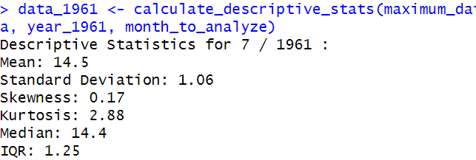 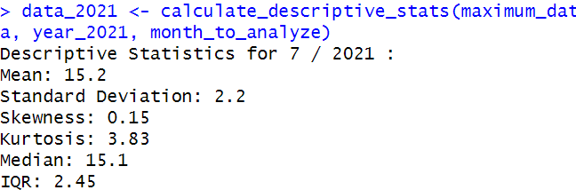

Looking at boxplots of the two time periods, we can do further analysis to better understand their distribution.

The boxplot for July 2021 exhibits greater variability, including a notable presence of outliers. It demonstrates a relatively right-skewed distribution, signifying that the majority of the data points are spread across a wider range compared to the boxplot for July 1961. Conversely, the boxplot for July 1961 is more compact, with the bulk of its data clustered around 15°C, and it displays a greater degree of right skewness when contrasted with the data from 2021. The dataset from 2021 shows that the temperatures for days in July ranged from around 9°C to just above 20°C, while from the same month in 1961, the day temperatures ranged from 12°C to 17°C.

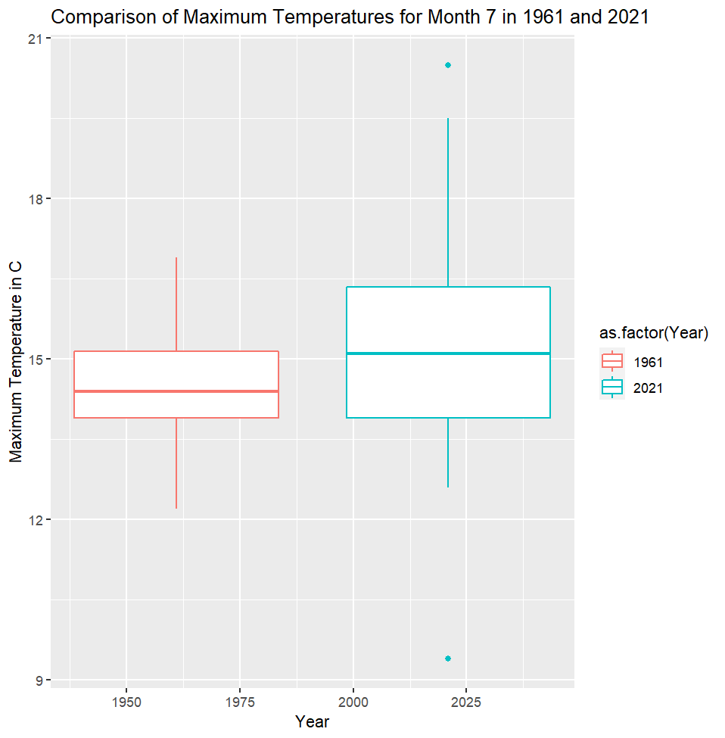

**Comparing daily range between maximal and minimal temperatures**

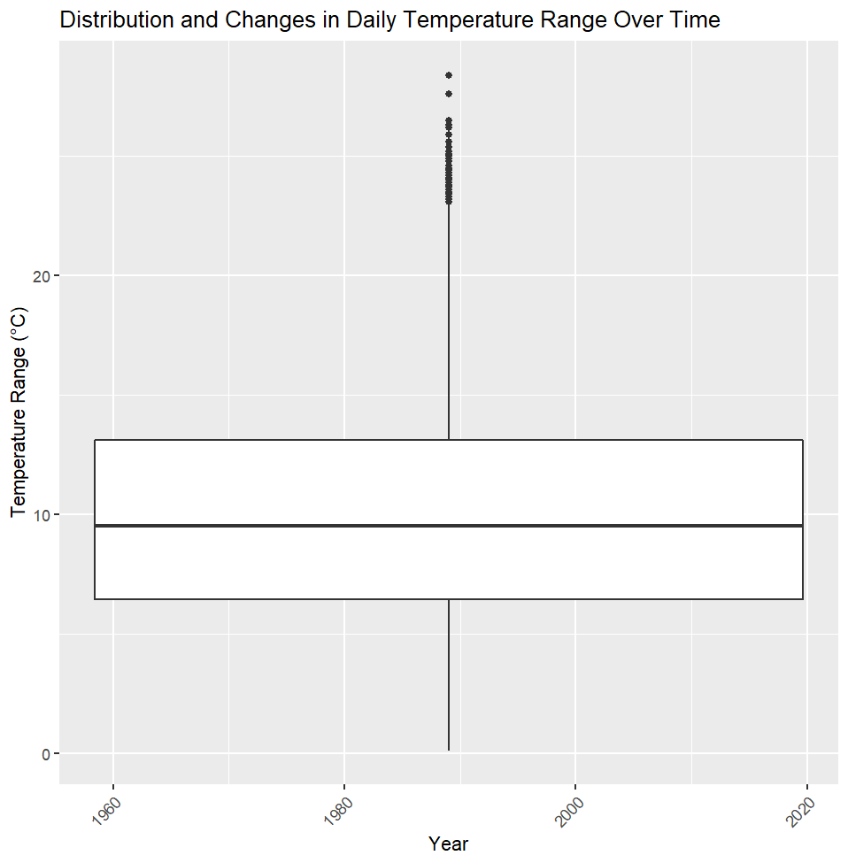 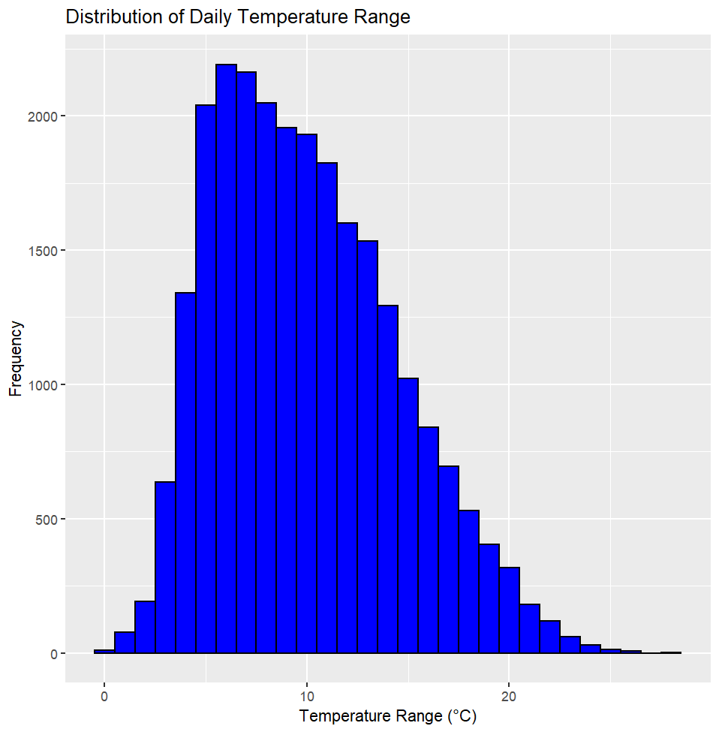

The provided visual representations depict the distribution of the daily temperature range in Adelaide. This range was computed by subtracting the nighttime temperatures from the daytime temperatures, that is, the minimum temperature data from the maximum temperature data.

As evidenced by the histogram, the average daily temperature variations, encompassing both daytime and nighttime, generally exhibit a limited range of approximately 10°C. However, from the presence of the outliers, it becomes apparent that there are exceptional instances in which the disparities between daytime and nighttime temperatures can be as substantial as 20°C.

The boxplot, as supported by the histogram above, suggests a heavy right skew distribution. There are also a few outliers where the daily range is above 20°C and the boxplot suggests that majority of the data lies between where daily range temperatures are 10°C.

**Further Analysis of the Data**

Further manipulation of the datasets provided for this analysis showed that there were more hot days in some years as compared to others. The table below outlines the count of days for each year wherein the maximum temperature equaled or exceeded 35°C. Additionally, these findings have been visually depicted through a bar graph for enhanced clarity.

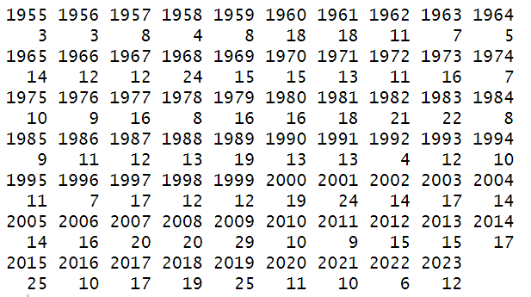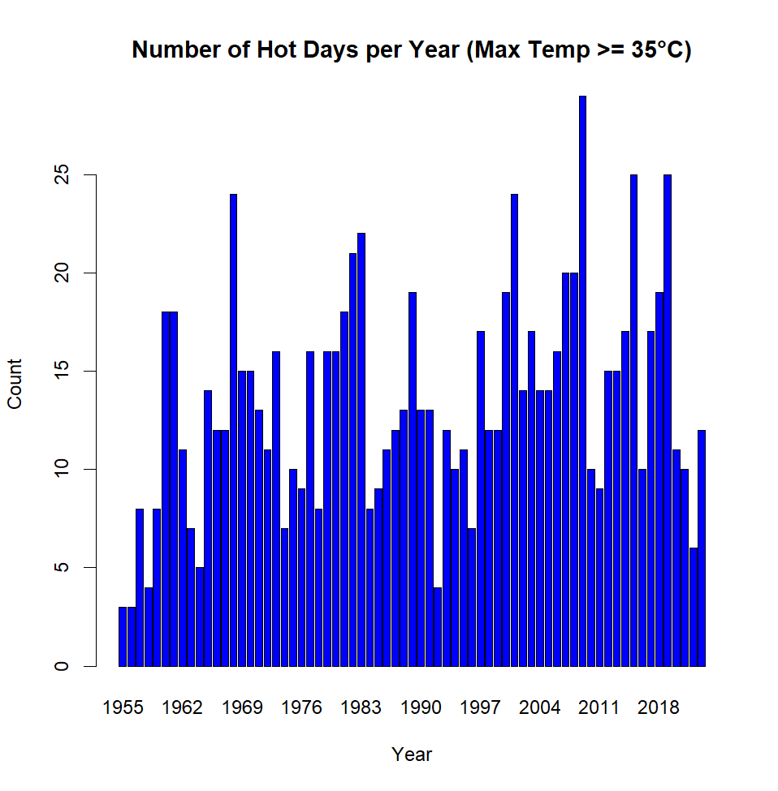

From the above, it is evident that the year 2009 stands out with the highest count of hot days, while 1955 and 1956 exhibited the fewest instances of such scorching temperatures. Additionally, the graphical representation reinforces this trend, displaying a gradual upward trajectory from left to right, suggesting that the number of hot days gradually increased over time. This supports the argument that that Adelaide's climate is indeed influenced by the phenomenon of global warming.

The same analysis was conducted for the night temperatures. The table below outlines the count of days for each year during which the minimum temperature dipped below 10°C. This selection was made in consideration of the previously computed temperature range, which revealed fluctuations of up to 20°C. Consequently, it was deemed pertinent to compare maximum temperatures of 30°C to minimum temperatures of 10°C. As with the prior analysis, a bar graph was used to visualize these results.

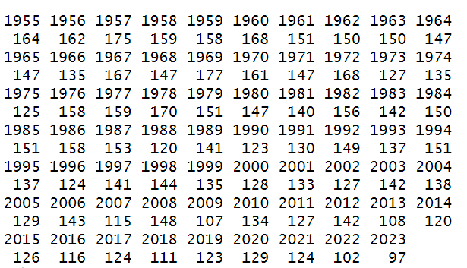 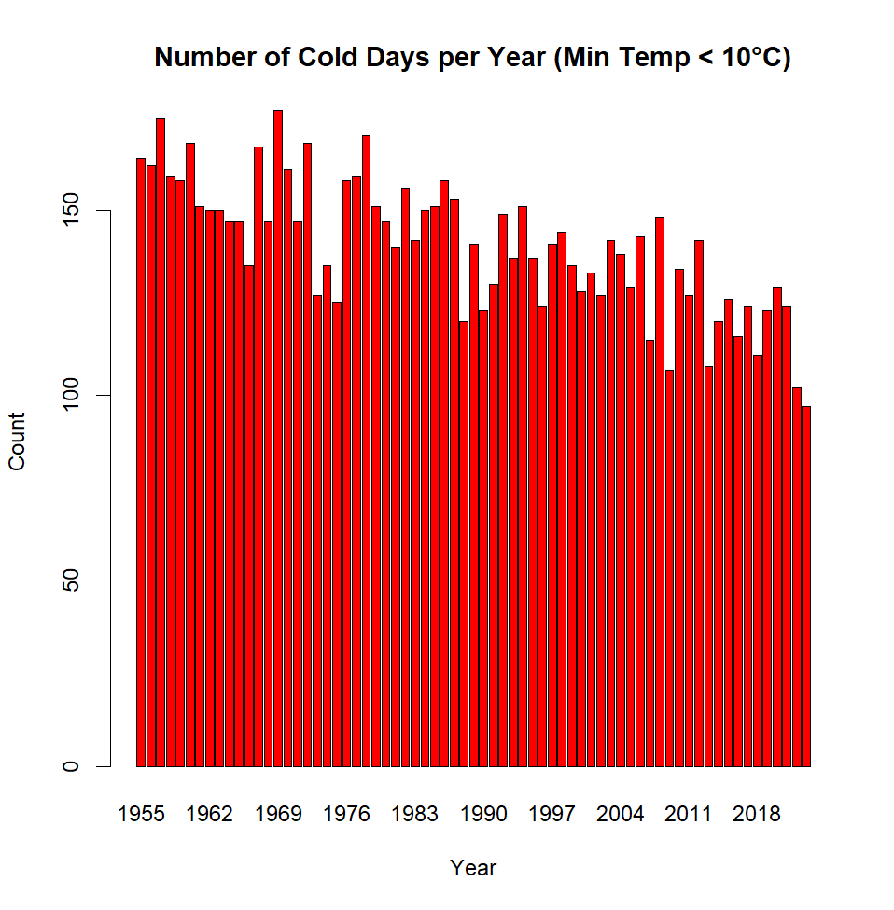

The data presented above underscores a conspicuous trend: the more recent years, spanning from 2018 to 2023, exhibited the lowest occurrence of cold days, while the earlier years, spanning from 1955 to 1960, registered the highest count of cold days. Correspondingly, the graphical representation reinforces this pattern, illustrating a gradual decline in cold days as one moves from left to right along the timeline. This gradual decrease over time substantiates the findings from the analysis of hot days and contributes further to the assertion that Adelaide's climate is indeed experiencing an annual warming trend, likely attributable to the influence of global warming.

Visualizing the two together painted a better portrait of the effect of global warming on the weather:

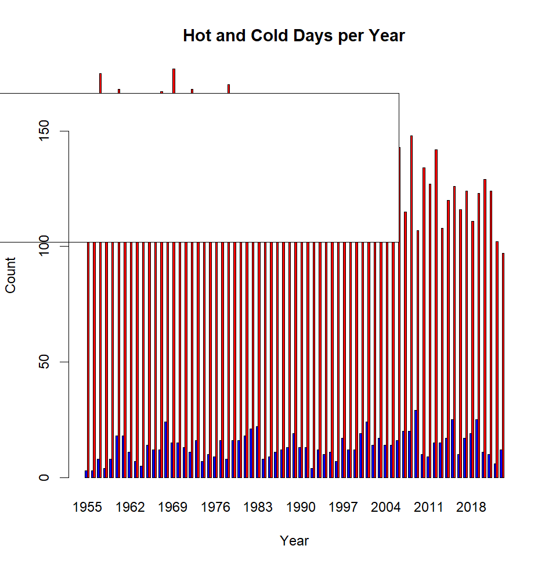

Global warming is characterized by climate change, that is, warmer temperatures and decreasing cold weather. As previously observed within the two datasets and further underscored by the graph presented above, there exists a discernible pattern. Specifically, there is a progressive rise in the frequency of hot days as one proceeds from the left to the right of the timeline. This trajectory indicates that the number of hot days has steadily increased over time. Conversely, there is a gradual reduction in the incidence of cold days as the timeline advances from left to right. This suggests a consistent decline in the number of cold days over time.

This compelling data strongly implies that the temperature fluctuations experienced in Adelaide over the past few decades may be a direct consequence of climate change, notably, the impact of global warming.

**Conclusion**

In conclusion, our comprehensive analysis of temperature data in Adelaide has provided compelling evidence of long-term climate trends, particularly in the context of global warming. By examining temperature variations over the years, we have observed significant shifts in both hot and cold days. Notably, there has been a gradual increase in the occurrence of hot days, suggesting a warming trend over time, and conversely, a decrease in the frequency of cold days. These findings align with the overarching climate change paradigm associated with global warming, wherein temperatures are on the rise, and extreme temperature events are becoming more common.

In addition, it's worth noting that there has been greater uncertainty in day temperatures, with fluctuations becoming more prominent. This heightened variability in day temperatures underscores the dynamic nature of Adelaide's climate, as it adapts to the effects of global warming.

The observed temperature fluctuations underscore the dynamic nature of Adelaide's climate, as it adapts to the effects of global warming. These changes have significant implications for the region's environment, agriculture, and overall way of life. As such, it becomes increasingly crucial for policymakers, scientists, and the community at large to address and mitigate the consequences of these temperature shifts, and to implement strategies aimed at minimizing the impact of climate change on the city and its residents.